Audio Video communication using
Ad hoc networking

Khyzar Hayat
Taimoor Javaid
Muhammad Farhan



DEPARTMENT OF COMPUTER SCIENCES
COMSATS UNIVERSITY ISLAMABAD, WAH CAMPUS
WAH CANTT – PAKISTAN

SESSION 2017-2021

Audio Video communication using
Ad hoc networking
Khyzar Hayat
REG.NO.CIIT/SP17-BSE-001/WAH
Taimoor Javaid
REG.NO.CIIT/SP17-BSE-002/WAH
Muhammad Farhan
REG.NO.CIIT/SP17-BSE-003/WAH

Supervised By:

DR NADIR SHAH

A DISSERTATION SUBMITTED AS A PARTIAL FULFILLMENT OF THE REQUIREMENTS FOR THE DEGREE OF BACHELORS IN COMPUTER SCIENCE / SOFTWARE ENGINEERING

DEPARTMENT OF COMPUTER SCIENCES
COMSATS UNIVERSITY ISLAMABAD, WAH CAMPUS
WAH CANTT – PAKISTAN

SESSION 2017-2021

FINAL APPROVAL

The department will provide the final approval page after the final evaluation.

DEDICATION

This project is dedicated to our beloved parents and teachers whose prayers and affection enabled us to be what we are today. I also dedicate this project to my many friends and family who have supported me throughout the process. I will always appreciate all they have done, especially DR NADIR SHAH for helping me develop my technology skills.

ACKNOWLEDGEMENT

We are primarily grateful to Almighty ALLAH, our parents and indebted to our supervisor “Dr. NADIR SHAH” for his backing and guidance.
We would like to proclaim our profound appreciation to all those who bestowed us the opportunity to finalize our final year project. We would also like to thank our parents who have given us the chance to study and acted as a backbone and a major reason behind our accomplishment.
Furthermore, we also acknowledge with much gratitude, the pivotal role of the Friends and Classmates. We must admire the counseling given by other supervisors, viva committees, particularly in project presentation that has enhanced our presentation skills.

PROJECT BRIEF

PROJECT NAME AUDIO VIDEO COMMUNICATION USING THE AD HOC NETWORKING

ORGANIZATION NAME COMSATS UNIVERSITY ISLAMABAD, WAH

OBJECTIVE TO COMMUNICATE BETWEEN NODES

UNDERTAKEN BY TAIMOOR JAVAID
KHYZIR HAYAT
MUHAMMAD FARHAN

SUPERVISED BY DR NADIR SHAH
ASSISTANT PROFESSOR
COMPUTER SCIENCE
COMSATS UNIVERSIT
ISLAMABAD, WAH

Started On MARCH 2020

Completed On DECEMBER 2020

COMPUTER USED DELL

SOURCE LANGUAGE JAVA

OPERATING SYSTEM LINUX OPERATING SYSTEM

TOOLS USED LINUX OS, NETBEANS, ECLIPS

ABSTRACT

Our project is based on the communication between the nodes using the ad hoc network communication. in this project we will provide the different type of communication like audio video and text messaging. As this project is based on the nodes connection so this communication is free of cost. this project is specially design for the organization who work for the same purpose.

TABLE OF CONTENTS

1 INTRODUCTION 11
1.1 System Introduction 2
1.2 Background of the System 2
1.3 Objectives of the System 3
1.4 Significance of the System 3
2 REQUIREMENT SPECIFICATIONS 4
2.1 Product Scope 5
2.2 Product Description 5
2.2.1 Product Perspective 6
2.2.2 Product Functionality 6
2.2.3 Users and Characteristics 6
2.2.4 Operating Environment 6
2.3 Specific Requirements 6
2.3.1 Functional Requirements 6
2.3.2 Behavioral Requirements 7
2.3.3 External Interface Requirements 8
2.4 Non-functional Requirements 9
2.4.1 Performance Requirements 9
2.4.2 Safety and Security Requirements 9
2.4.3 Software Quality Attributes 9
3 DESIGN SPECIFICATIONS 11
3.1 Introduction 12
3.2 Composite Viewpoint 12
3.3 Logical Viewpoint 14
3.4 Information Viewpoint 14
3.5 Interaction Viewpoint 15
3.6 State Dynamics Viewpoint 16
3.7 Algorithmic Viewpoint 16
4 DEVELOPMENT AND TOOLS 17
4.1 Introduction 18
4.2 Development Plan 18
4.3 Development Tools 18
4.4 Conclusion and Future Work/Extensions 19
5 QUALITY ASSURANCE 20
5.1 Introduction 21
5.2 Traceability Matrix 21
5.3 Test Plan 22
6 USER MANUAL 23
6.1 Introduction 24
6.2 Hardware/Software Requirements for the System 24
6.3 Installation guide for Application 24

Chapter 1

INTRODUCTION

Introduction

  - System Introduction
Technology has changed the way we communicate in so many ways. It has also changed the way people conduct business, and the manner we conduct our personal and social lives. We can easily text, talk and email through a link to anyone all over the world. This project is also relating to communication between different nodes (Peers). In this project we are creating the local area network using ad hoc network communication (node to node). Project based on three major modules these allow the user to communicate by text message, voice message and live streaming video without the cost of the network charges. The user should be those who are specified in the application before the communication. The user can communicate the other user in the different situation. All users in this system consider as Nodes (Peers) and each of them can talk to other or view others stream. This system will work when self-establishing network (ad hoc network) connect the multiple nodes at the same time.

  - Background of the System
1 Our main objective for building this system is to achieve flooding free routing.
- Flooding is a simple routing technique in computer networks where a source or node sends packets through every outgoing link. Flooding, which is similar to broadcasting, occurs when source packets (without routing data) are transmitted to all attached network nodes. Because flooding uses every path in the network, the shortest path is also used. The flooding algorithm is easy to implement.
- Flooding can be costly in terms of wasted bandwidth. While a message may only have one destination it has to be sent to every host. In the case of a ping flood or a denial-of-service attack, it can be harmful to the reliability of a computer network. Messages can become duplicated in the network further increasing the load on the network as well as requiring an increase in processing complexity to disregard duplicate messages.
- To overcome this issue, we are using a flooding free protocol designed by our supervisor Dr. Nadir Shah instead of using old protocols like OLSR RIP IS-IS etc...
  - Objectives of the System

Main objectives of the systems are:
- To achieve flooding free routes
- Communication using Ad hoc Network
- Establish the connection between specific area
- Each node or user can communicate three different ways
- Text Messages
- Audio communication
- Video streaming

  - Significance of the System

This project allows the user to communicate in the short area without any network charges. This project allows the user to communicate directly without the interruptions of the 3rd party. This project will allow the user a local platform for multiple people's communication that are working for the same purpose. This project could be helpful for defense. This system will be helpful in the military operations (like rescue missions where regular network are necessary to jam) by providing the local and secure communication way. This system will allow the user admin to watch through every node and guide the user according to the others.

CHAPTER 2

REQIREMENTS AND SPECIFICATIONS

Requirements and Specifications

2.1 Product Scope
Scope of this system is that this software will be applicable in limited and controlled environment means each node will be at defined position it establishes the link to its nearest one.

2.2 Product Description

2.2.1 Product Perspective

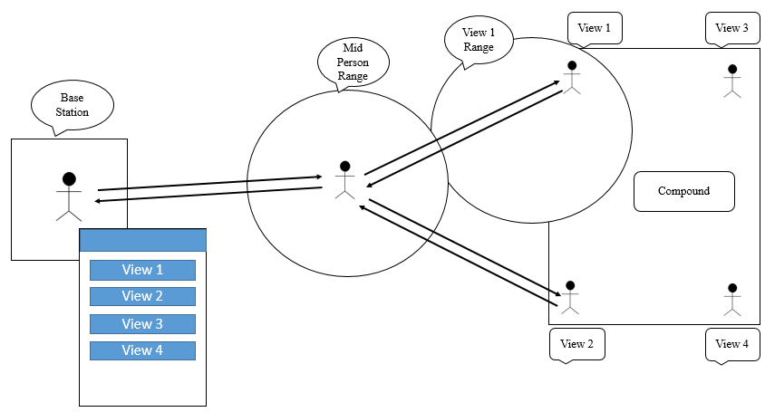

2.2.2 Product Functionality

Major functionalities of Project are
- To reestablish the connection itself if it disconnects due to some reason.
- Text messaging
- Voice messaging
- Video call live streaming.
Above mention modules works on the rules of ad hoc network communication. if any node removes from the path the other node reestablishes the connection and fulfil the remover’s node gape.

2.2.3 Users and Characteristics
this system of node communication is specially mode for those people who
works for the same organization.

2.2.4 Operating Environment

- NetBeans or Eclipse
- Java
- Windows 10
- Latest version of all libraries
- Camera Laptop

2.3 Specific Requirements

2.3.1 Functional Requirements
The functional requirement of this project is based in the three major modules.
- Nodes are range in range of each other.
- Text messaging: user can write the message and share with the others user. Function related to this operation: this operation of text messaging works when the connection between the neighbor nodes is conformed. If connection is disconnecting, then user receive an error response message and product first set up the connection and send this text message again.
- voice messaging: the voice messaging work same as text message but if the voice is more than to handle the data for that different ways can be used at the same time like the voice message can the convert in to the packets and then send this small packet using the multiple way that leads this message to the admin.
- The live call streaming: this module works same as the voice messaging. But camera is necessary for this module.

2.3.2 Behavioral Requirements

USE CASE DIAGRAM
- The admin can view the live streaming of all the node .
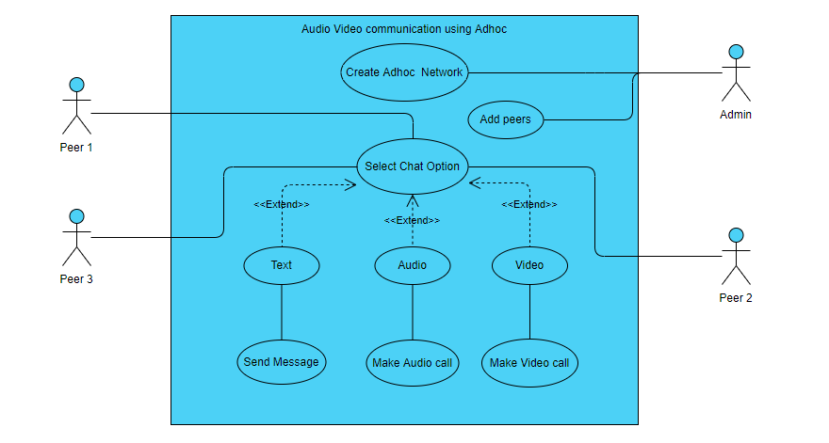

2.3.3 External Interface Requirements

2.3.3.2 User Interface
This product gives the user related control on the main screen interface.
- User can select type of communication which he/she want like text messaging, audio, or video.
- User can write and read messages in message module
- User can make or receive audio call.
- User can make or view live streams of other nodes

2.3.3.2 Hardware Interfaces

2.3.3.3 Enrollment Module

This product will provide the cost-free and secure
Communication without the large infrastructure
2.3.3.4 Database Module

Not database involved in this project.

2.3.3.5 Verification Module

No verification required.

2.3.3.6 Screen Module:

Each user can view the other nodes activities.

2.3.3.7 Software Interfaces

- Windows (Platform)
- NetBeans (Tool)
- Java (Language)
- The Adhoc network technologies will help to create the connection without the hardware infrastructure.
- web cam capture(library) helps to capture the camara activities.

2.3.3.8 Communications Interfaces

All the interfaces are connected to one main interface. To get access to these
interfaces you need to get access to main interface.
In this project there are three modules connected to a one main interface. the main interface will allow the user to select option for different communication interfaces. after getting the access to the main interface the user can connect to the other interfaces that are the part of this project and can

2.4 Non-functional Requirements
2.4.1 Performance Requirements
- System has ability to maintain connection if any node disappears from the way.
- System should generate a message if any node disappears from network.
- System should choose closest path to send the packets from source node to destination node.
- System should not allow 3rd party to enter the network
2.4.2 Safety and Security Requirements
For the safety of system, following security measurements should be implemented:
- System will use secure security protocols.
- No one should be able to hack or make influence in network.
- 3rd party should not access network.
- System should be secure all the times.
- No one from outside can encrypt or decrypt messages in network
2.4.3 Software Quality Attributes
2.4.3.1. Portability
Only designed for Linux operating system
2.4.3.2. Robustness
System should recover from any un-expected errors.
2.4.3.3. Visibility
System results should be visible, and any action’s outcome should be clear.
2.4.3.4. Reliability
System should be very reliable and free from any programming errors and bugs.
2.4.3.5. Maintainability
System should be maintainable and can accommodate any changes if any occurs in later time.
2.4.3.6. Testability
System should be testified and cleared from any bugs and errors.
2.4.3.7. Adaptability
System should be easy to understand and easily adaptable by its end users.

Chapter 3

Design Specifications

3. Design Specifications

3.1 Introduction

Users select option from Application interface which module want to run either Text Message, Audio or Video. All these communications will be held through Adhoc network. If user selection is video streaming camera capture image and pass it to server. If user selection is Audio camera capture audio form mice and pass it to next node through self-created network.
3.2 Composite Viewpoint

3.2.1 Package Diagram

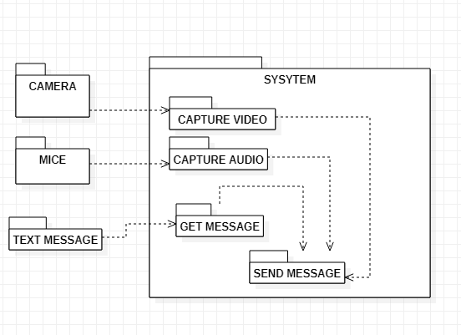

Fig4. Package Diagram

3.2.2 Deployment Diagram

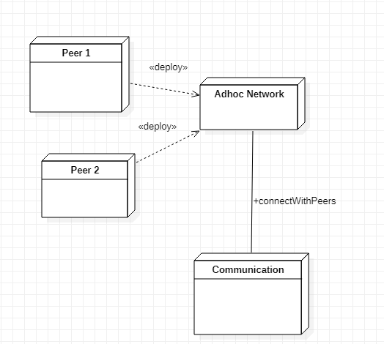

Fig5. Package Diagram

3.3 Logical Viewpoint

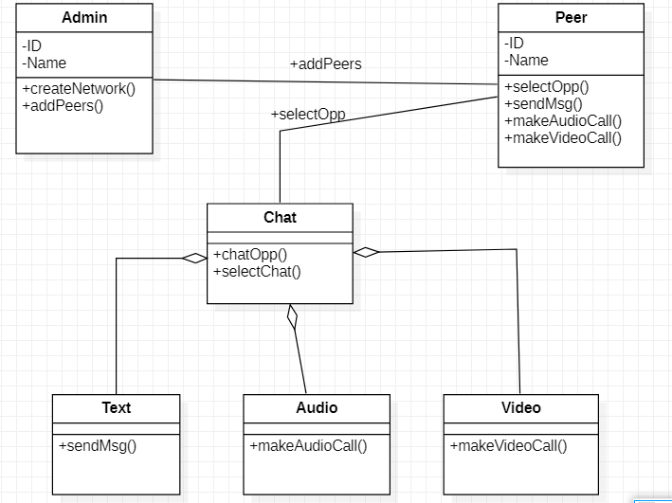
3.3.1 Class Diagram

Fig6. Package Diagram

3.4 Information Viewpoint

3.4.1 ER Diagram

No database in our project

3.5 Interaction Viewpoint

3.5.1 Sequence Diagram

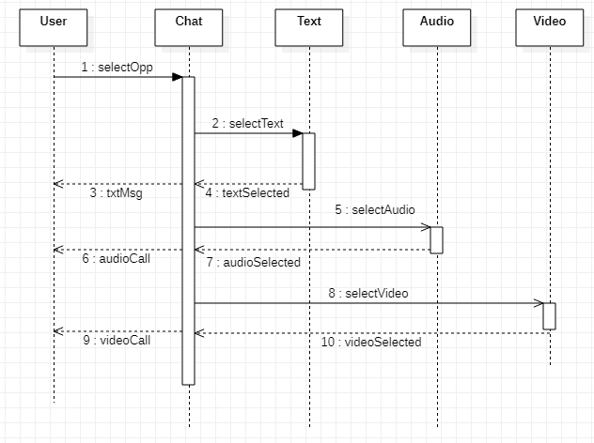

Fig7. Sequence Diagram

3.6 State Dynamics Viewpoint

3.6.1 UML State Machine Diagram

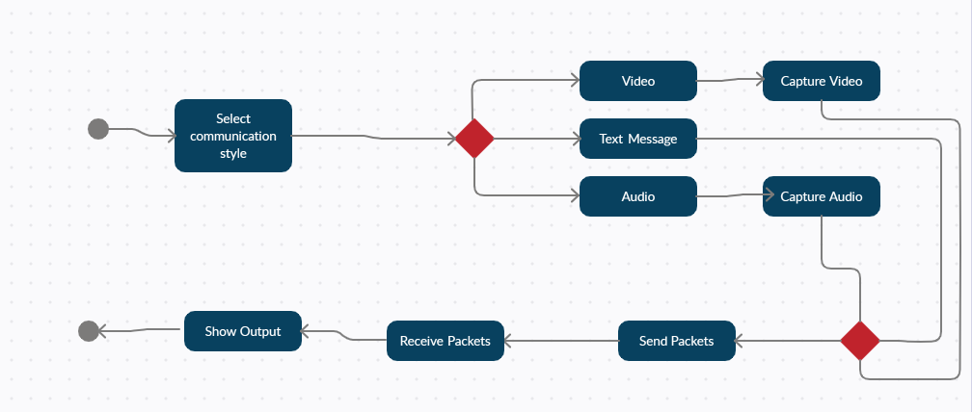

Fig8. UML Diagram

3.7 Algorithmic Viewpoint

1. Start.
2. show options for communication.
3. select the required options.
4. start communication.
5. End

Chapter 4

Development and Tools

4 DEVELOPMENT AND TOOLS

4.1 Introduction

Users select option from Application interface which module want to run either Text Message, Audio or Video. All these communications will be held through Adhoc network. If user selection is video streaming camera capture image and pass it to server. If user selection is Audio, capture audio form mice and pass it to next node through self-created network. Or if user select Text Message option take data from user and send it next node.

4.2 Development Plan
A team of three members develops this project. Each member creates his module
  - Khyzar Hayat
  - Taimoor Javaid
  - Muhammad Farhan
4.2.1 Breakdown Structure
  - Research on Project
  - Installing Development tools
  - Understanding of tools
  - Working on code
  - Integrating three modules in one software
  - Testing

4.3 Development Tools
- Linux OS
- NetBeans
- eclipse
- Camera

4.4 Conclusion and Future Work/Extensions

Our project allows the three kind of communication using the ad hoc networking.
1) Text messaging.
2) Audio communication.
3) Live streaming.

4.4.1 Future Work/Extensions

This project can be extending to the public as a local network for that high level infrastructure is required. this project also can be extending to android and another operating system.

Chapter 5

Quality Assurance

5 QUALITY ASSURANCE

5.1 Introduction

We applied black box testing to ensure quality and error free output. We tested our project by creating the node connection at different range. Finally result that extract from the testing is that we need the special made wide range devices. These wide range devices help to create the strong communication without the connection loss in the live streaming.

5.2 Traceability Matrix

Fig9. Table for Traceability Matrix

Requirement Traceability Matrix
 | Test case ID | Test case 1  Response time | Test case 2  Error Free | Test case for Requirement
Requirement ID
Results should be clear |  |  | × | 2
Authorization |  |  |  | 1
Reliability |  | × | × | 2
Efficient |  | × |  | 1

5.3 Test Plan

Table 5.3.1: Test case for Reliability
Test ID | 1
Test name | Reliability
Date of test | 10/12/2020
Name of application
Description | If the nodes disconnect due to any reason the node should have the ability to reconnect.
Input | Connection establishes at different range.
Expected output | Connect at different distance
Actual output | Connection maintain at the range of device range.
Test Role (Actor) | Team Member
Test verified by | Team Member/Supervisor

Table 5.3.2: Test case for Response Time
Test ID | 2
Test name | Response Time
Date of test | 10/11/2020
Name of application | Audio video communication.
Description | Connection establishment and communication testing.
Input | Connect again and again at different distance.
Expected output | Connect at the range of device range and provide the batter result of communication.
Actual output | 10 to 15
Test Role (Actor) | Team Member
Test verified by | Team Member/Supervisor

Chapter 6

User Manual

6.1 Introduction

It will help users to install all necessary tools required to run this system and will guide the user thoroughly how to use this system.
This manual helps the user to install the necessary tools required for this system and guide the user how to use this system.

6.2 Hardware/Software Requirements for the System

- NetBeans (java language)
- Library (web-cam capture)
- Laptop with camara
- Linux operating system
- Nodes connection
- Wireless Connection between different nodes.

6.3 Installation guide for Application

Install the Linux operating system


Install the NetBeans.
Fig11. Download IDE
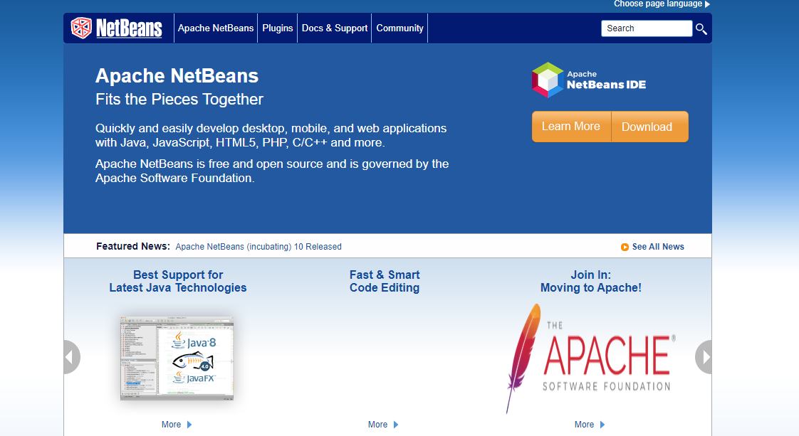

- Download Library from webcam-capture-0.3.10-dist.zip

- Fig12. Libraries Installation
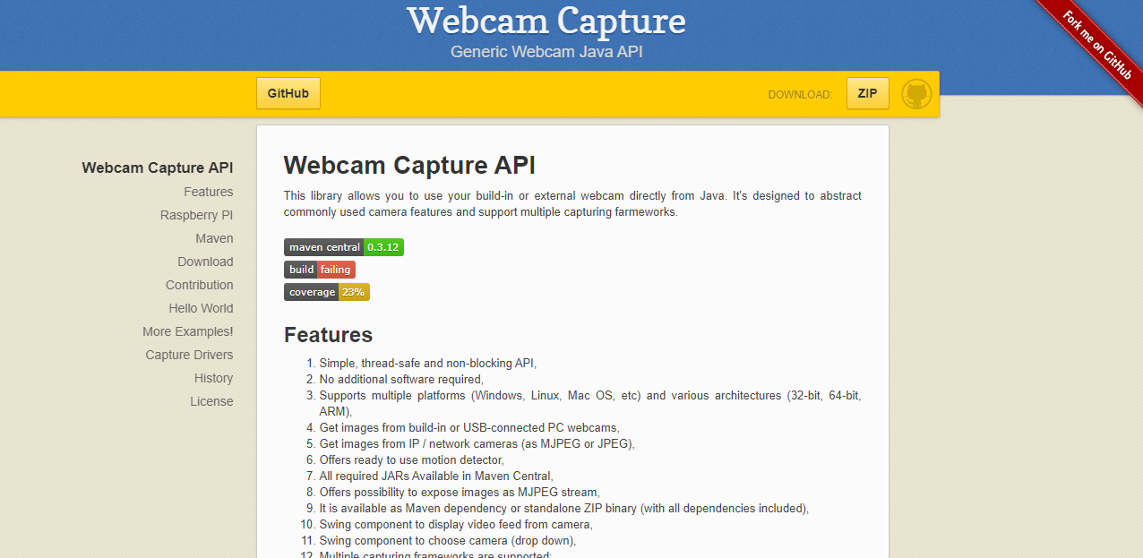

- Download IDE

Fig13. Download IDE

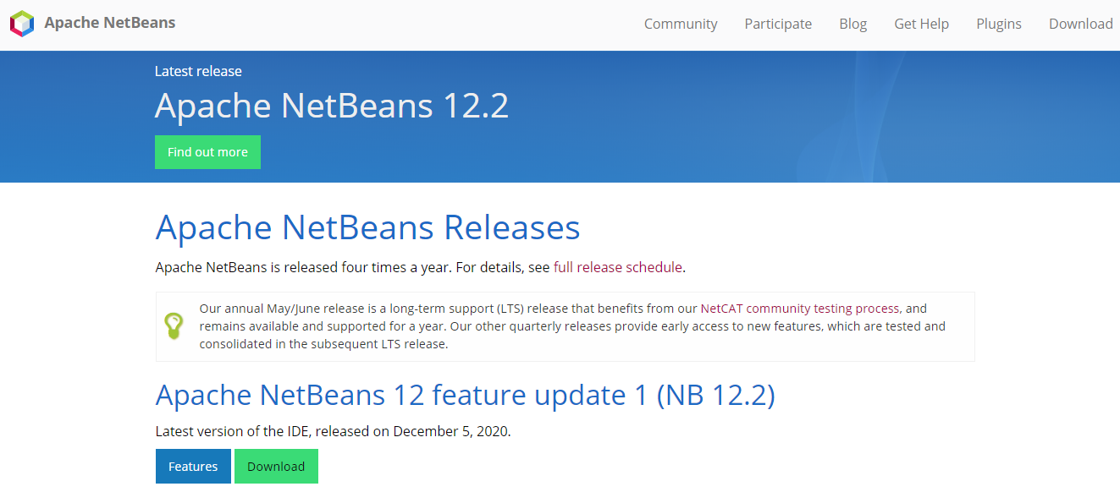

- Live Demo

- Fig14. Sample

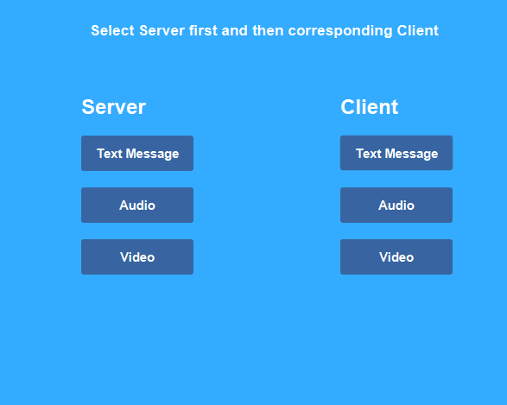

Fig15. Sample

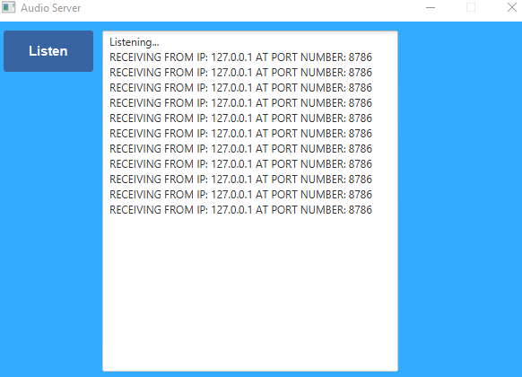

Fig16. Sample

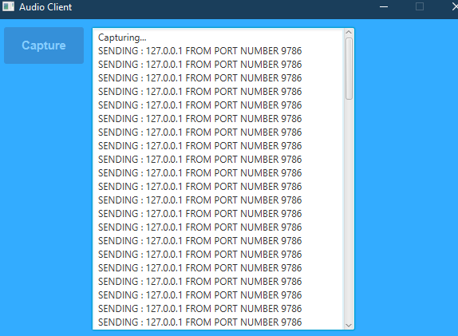

Fig17. Sample

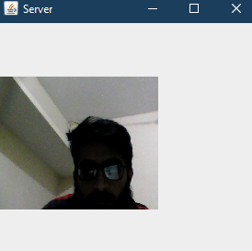

Fig18. Sample

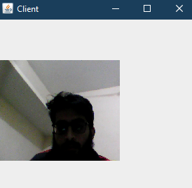

References

    - Webcam Capture in Java (sarxos.pl)

    - webcam-capture/DetectWebcamExample.java at master · sarxos/webcam-capture · GitHub

    - sockets - Live audio stream java - Stack Overflow

